ID:24298

NAME: MANDALI Innocent

Q1. This script creates 10 users named mandali1 to mandali10 alternating with the number 1 to 10 .The created users are to change password as soon as they log in then,  
I set that their account will expire at the end of March this year.

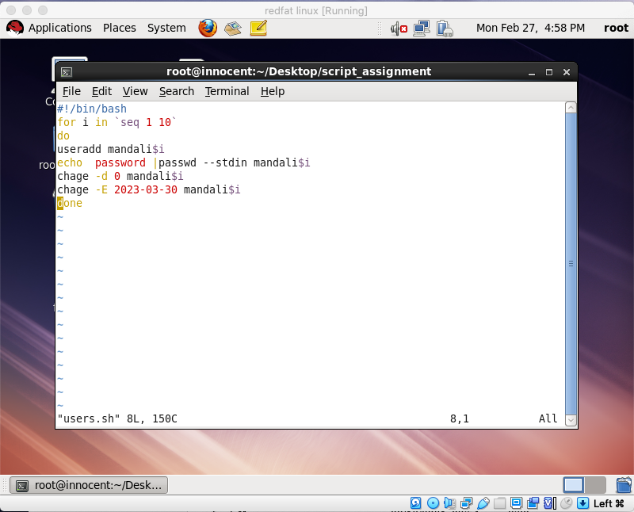

The script was successful as shown below 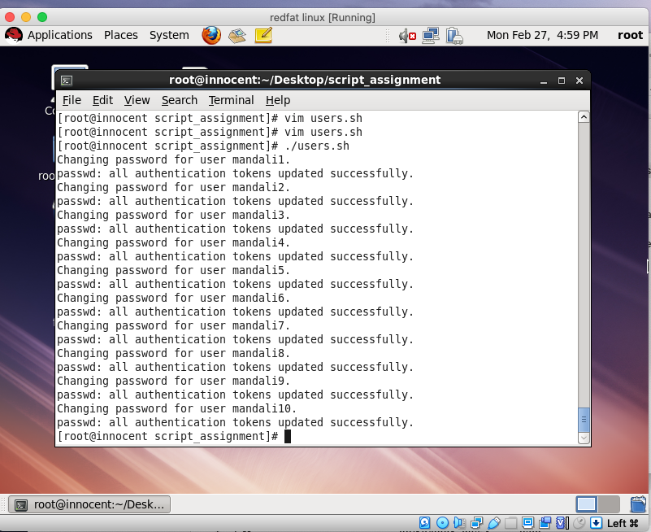

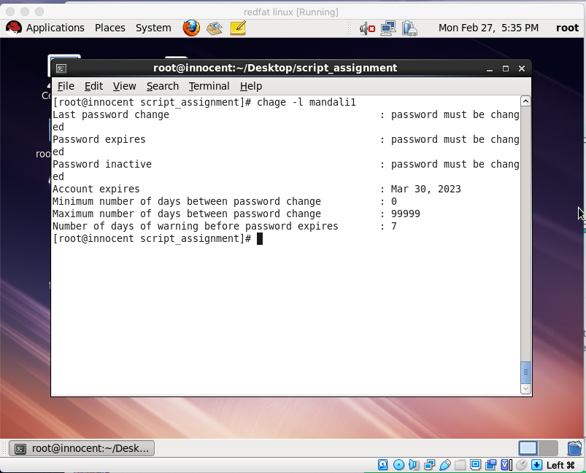

Q3.

This script displays the memory and CPU usage and sorts from most consuming

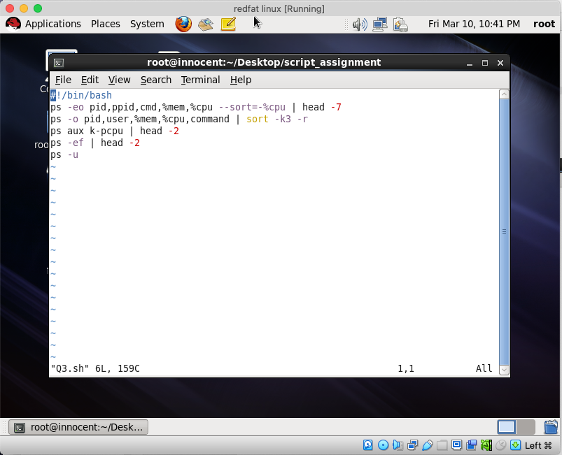

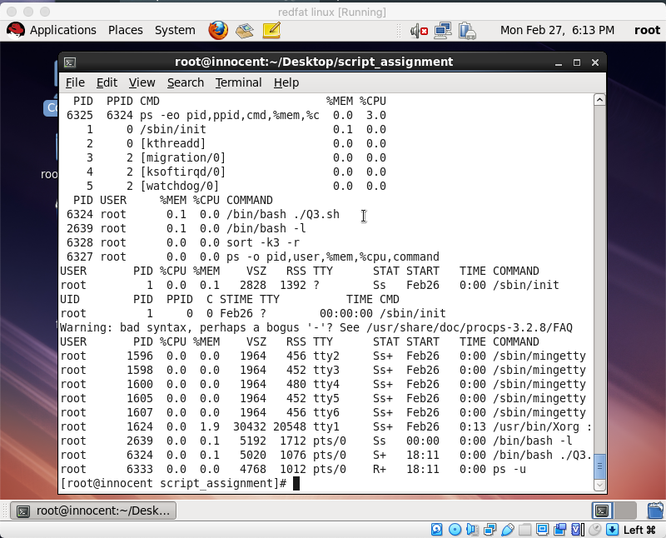.

Q4.

This script creates backup of my users files on the NAS (Remote desktop) using secure copy (scp) with help of SSH keys

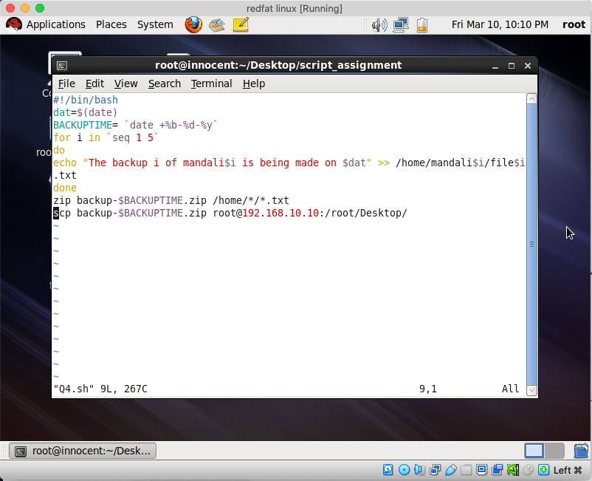

This is where the backup.zip file in another desktop

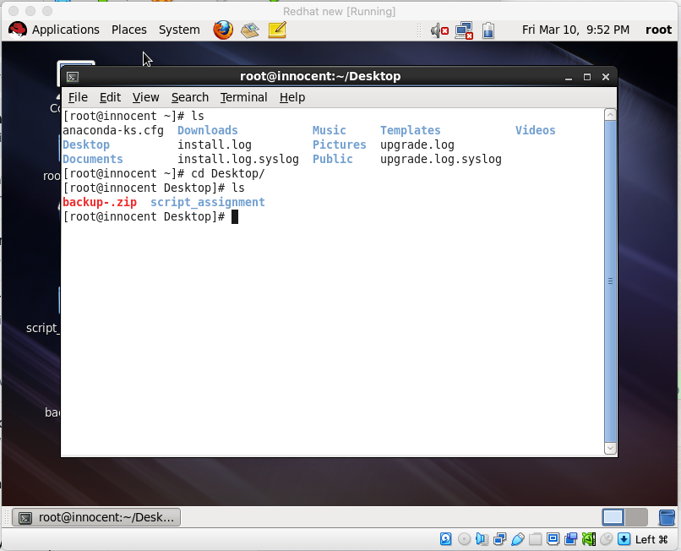

Q5.

This compares two files, if they different, it syncs them.

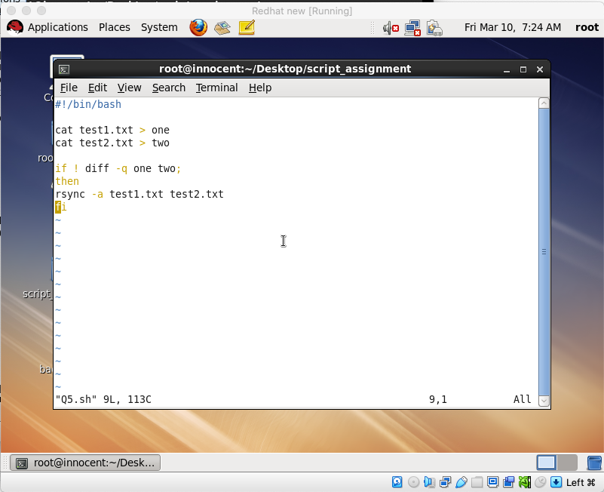

The files have been synced

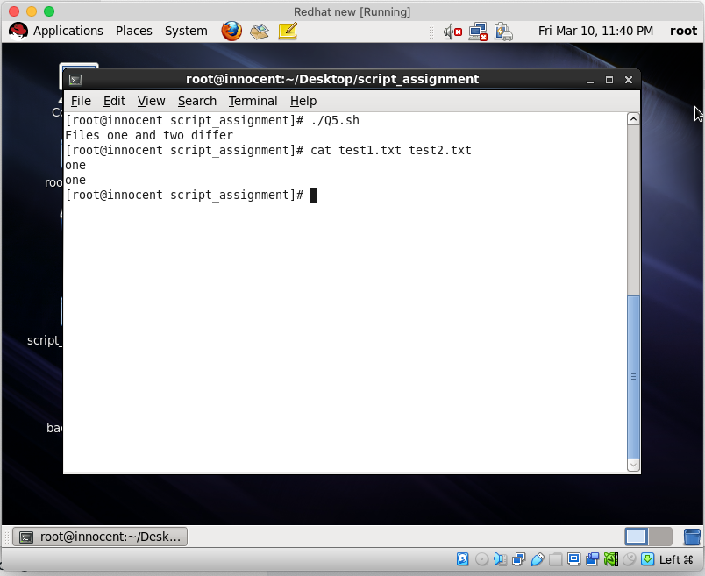

Thank you.